Irish Presidents - Answers

Part A:

The Presidents.
Name | Year Started Office | Year Finished Office | Year of Birth | Year of Death | Place of Birth | Number of Terms
Douglas Hyde | 1938 | 1945 | 1860 | 1949 | Roscommon | 1
Sean T. O’Kelly | 1945 | 1959 | 1882 | 1966 | Dublin | 2
Eamon de Valera | 1959 | 1973 | 1882 | 1975 | New York | 2
Erskine Childers | 1973 | 1974 | 1905 | 1974 | London | 1
Cearbhall Ó Dálaigh | 1974 | 1976 | 1911 | 1978 | Dublin | 1
Patrick Hillery | 1976 | 1990 | 1923 |  | Clare | 2
Mary Robinson | 1990 | 1997 | 1944 |  | Ballina | 1
Mary McAleese | 1997 |  | 1951 |  | Belfast | 1

Pictures:

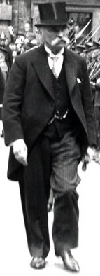 | 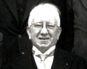 | 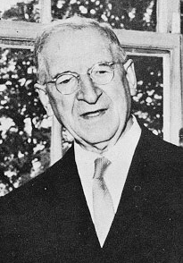 | 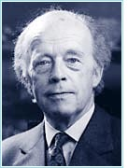
Douglas Hyde | Sean T. O’Kelly | Eamon de Valera | Erskine Childers
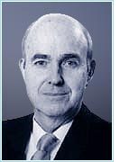 | 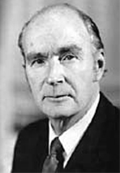 | 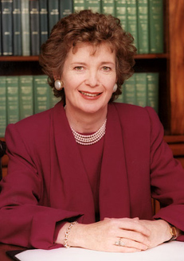 | 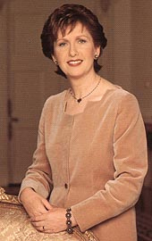
Cearbhall Ó Dálaigh | Patrick Hillery | Mary Robinson | Mary McAleese

Part B:
Role and Responsibilities:

Question | Answer
What are the two main roles of the President? | 1. Irish Head of State
What are the two main roles of the President? | 2. Guardian of the people’s rights
How long is a term of office? | 7 years
Where does the inauguration ceremony take place? | Dublin Castle
Name three appointments the President makes: | 1. Taoiseach (Irish Prime Minister)
Name three appointments the President makes: | 2. Judges
Name three appointments the President makes: | 3. Officers of the Defence Forces
May the President travel abroad freely? | No – only with the permission of the Government.
Which President died after only 1 year and 5 months in office? | Erskine Childers
Who was the first female President? | Mary Robinson

Part C:
Visitors.

In which year did the school visit take place? | 2000
What gift did the students give to the President? | A hamper of Torc chocolates and goodies
Who was the President’s Aide-de-Camp? | Mrs Patricia O’Connor
Go to www.dictionary.com  What is the meaning of this word: -  Aide-de-camp | A military officer acting as secretary and confidential assistant to a superior officer of general or flag rank
What Irish singer and band have visited Áras an Uachtarán? | Bono and U2
Name a member of the British Royal family who visited the President? | Prince Charles

Part D:
Áras an Uachtarán.

What symbol is on the carpet in the Entrance Hall? | Gold Harp
What is on the centre of the mantelpiece in the Library? | Clock
What musical instrument is in the State Drawing Room? | Grand Piano
What is the main colour of the carpet in the State Reception Room? | Green
How many paintings on the wall in the President’s Room? | 7
Can you guess who the people are in each painting?  Whose portrait will be next? | The seven previous Presidents.  Mary McAleese.

